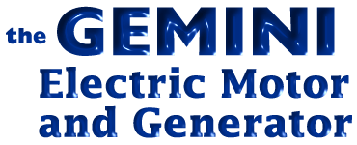

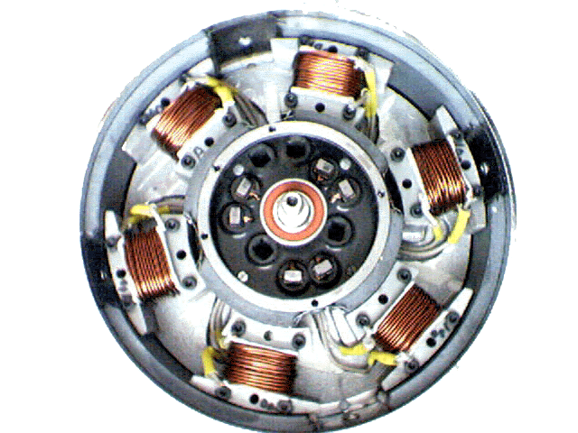

BUSINESS PLAN

GEMINI ELECTRIC MOTOR COMPANY PTY.LTD.
acn 092 633 246
53 Branksome terrace
Dover Gardens. South Australia. 5048
Telephone. 61 - 8 - 82981698
Fax. 61 - 8 - 82989080

ABN No. 58 092 633 246

www.geminielectricmotor.com

BUSINESS PLAN

Summary

- Company and Industry

- Patents

- The Market

- Marketing

- Management

- Development Plan

- Overall schedule

- Risks

- Financial Statement and Projections

- Appendix

Summary

Most Experts agree that the finite resources of Oil, Coal and Natural Gas are

running out, that new reserves are not being found as quickly as old reserves are

drying up, and with the demand steadily increasing in China, India and the Asia region

to satisfy their rapidly increasing usage and improved standard of living there simply is

not enough fossil fuel to go around.

Solutions and alternative energy resources have to be found.

One Solution has been the GEMINI ELECTRIC MOTOR or GENERATOR, by using

both magnetic poles created by the energized coils, when an electric current is applied,

the GEMINI ELECTRIC MOTOR has the potential to produce twice the electric current

from a given source when used as a generator, and to use half the electric current to

produce the same amount of torque when used as an electric motor.

When the Gemini Electric Generator is driven by a source such as Wind energy, steam

created by Hot Rocks, thermal energy or Solar energy, or by water movement such as

Tidal, Wave or River Flow, or some other renewable energies, the reduction in harmful

Green House Gasses is significant.

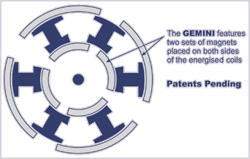

INPEX Invention & New Products Exposition - Pittsburgh - U.S.A. - May 2004

awarded to the
GEMINI ELECTRIC MOTOR
for Innovation Excellence
at INPEX Exhibition
Awarded to the Ettridge Commutator

at the International Exhibition for Inventions and New Products held in Geneva, Switzerland, March 2004.

John Ettridge’s Gemini Electric Motor Technology
John Ettridge in collaboration with Tim Harwood M.A.

Electric motor technology has remained surprisingly static over the last 50 years. While there are a number of good reasons for conservatism in any design process, perhaps the most significant point is that it is only relatively recently permanent magnets have become cheap enough, and rugged enough, to be appropriate for motor design.

Up until the 1940s it was still customary to use electromagnets, as permanent magnets were not considered suitable for the demands of commercial applications. And it took even longer for magnets to be made available for low cost private experimentation. The result was an industry that became surprisingly fixed in its ways, for which innovation could only come from the outside.

While switched reluctance motors have found increasing popularity in recent years, as the advantage of high efficiency becomes more widely appreciated, the traditional prejudice of motor designers against permanent magnets, means this area of switched reluctance research is still relatively unexplored.

John Ettridge is an inventor who has invested the time required to pursue permanent magnet based switched reluctance design. His research began out of frustration with conventional designs, which it seemed to him were grossly inefficient, difficult to repair, and unimaginative.

Figure 1 is taken directly from the Ettridge patent, and illustrates the layouts pursued in the early stages of research. Subsequently a variety of alternative geometrical layouts were developed, optimized for specific applications and load scenarios. When the six coils are aligned with the permanent magnets, an input pulse is provided to the apparatus, that manifests a repulsion effect, pushing the stators away from the permanent magnets. The input voltage will determine the characteristics of the recession. The higher the input voltage, the greater the resultant mechanical force manifested.

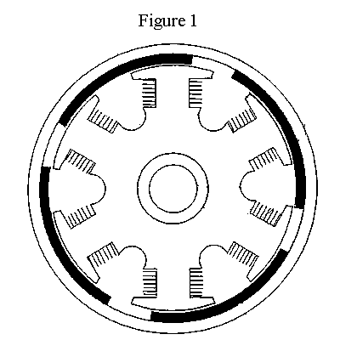

While the use of permanent magnets in such a manner is innovative, the Ettridge technology features further levels of design optimization. Figure 2 illustrates how the conventional T shaped stator can be replaced with an H shaped stator. This enables both ends of an energized coil to be used to impart motion to the rotor section.

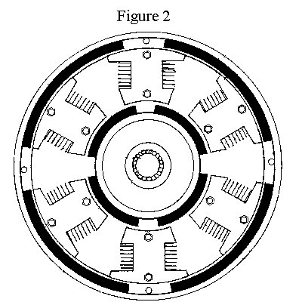

Figure 3 places the two stator designs side by side to highlight the novelty in design. The resultant increase in efficiency and improvement in power to weight ratio, means the overall effectiveness of the technology is greatly enhanced, without incurring a significant increase in manufacturing costs.
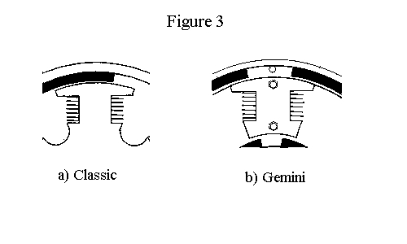
Independent support for this view was sought from Paul Chandler, Research Engineer of the Northern Territory Center for Energy Research, part of the Northern Territory University. He stated the following on July 18th 2000:

The general theory is that permanent magnet (PM) machines are capable of producing higher efficiencies over other such as induction motors and reluctance motors. They can be very robust and produce a large torque for their physical size. The revolutionary feature of the GEMINI motor is that it has the capability of producing more power for the same volume. Theoretically, it is capable of handling twice the power of a same size conventional motor and while doing so, remain at the high efficiencies that PM motors are capable of. A reduction in size comes with the obvious benefit of material reduction, hence savings in weight and cost. A less obvious advantage is in that a reduction in size opens up markets where space limitations have previously led to the use of costly and inefficient transmission systems. The manufacturing principles of the GEMINI motor are conventional in fashion and would require a minimal retooling cost as compared with other novel motors emerging from the field of research.

Flux Paths

Permanent magnets require a complete flux path between the poles, and unless the motor provides a path for these vectors, the flux lines are completed through air. If lines of force permeate the apparatus in such a fashion, the result may be to cause drag upon the rotor, and reduce the efficiency of the device.

In a device such as an electric motor where fields are in a constant state of change, the net loss in performance from undirected lines of magnetic force can be significant. This is perhaps another reason why electrical engineers have avoided permanent magnets in motor design, as they introduce not only expense, but also additional design challenges.

The Ettridge solution to this issue illustrated in Figure 4, is to provide the motor with a magnetically permeable back plate, which acts to contain the magnetic lines of force of the permanent magnets. This ensures the magnetic signature of the technology is relatively clean, and the rotor action can function without excessive magnetic drag. It also means the magnetic fields have to cross only 2 air gaps, as opposed to a more conventional 4. Therefore, a further principal of the Ettridge motor technology, is the creation of a magnetic flux circuit.
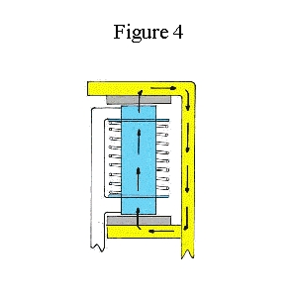

Energy Recovery

A further development of the Ettridge technology, was the integration of a regenerative capability. Apparatus was developed that enabled current to be extracted from the motor while in operation, without placing a load upon the motor. While many motors feature an ability to draw energy from the motor while breaking or other low load scenarios, the Gemini motor can produce a real output at all times, even while under heavy load. This output can be fed back into the motor, or used to recharge the source, and augments the efficiency gains already apparent in the design. A number of different implementations exist for this method, and one is illustrated in Figure 5, taken from the patent.
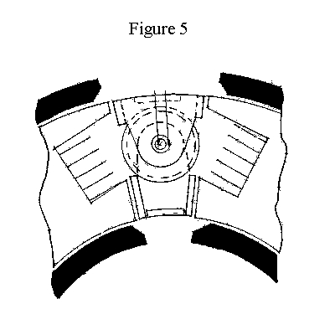
Summary

The patented Ettridge Gemini electric motor technology features a number of innovative design characteristics, that are likely to become increasingly common in the next generation of electric motors. Not only can significant efficiency gains be realized, but more importantly for many applications, power to weight ratios can also be improved. With this in mind, it is likely the commercial popularity of electric motor technology will only increase in the years ahead.

GOLD MEDALS were Awarded for the :
Ettridge Commutator at the International Invention and New Products Exhibition held at Geneva, Switzerland, May 2004.
and for the:
Gemini Electric Motor at the INPEX 2004, The Invention Show, held at Pittsburgh, Pennsylvania, U.S.A.

References

http://www.geminielectricmotor.com
International Patent Application number, PCT/AU01/00707, 13 June 2001

Company and Industry

Gemini Electric Motor Company Pty.Ltd. was incorporated on 1st May 2000, to Develop

and Market a new energy efficient electric motor, invented by John Patrick Ettridge.

Gemini Electric Motor Company Pty.Ltd. obtained a sole Manufacturing and Marketing

License from Ettridge Motors Pty.Ltd (a patent holding company ), which will receive a

royalty of forty per cent (40%) of any lump sum payment or royalty received by Gemini

Electric Motor Company Pty.Ltd. in respect of the invention covered by the patents.

Gemini Electric Motor Company Pty.Ltd. has been doing the Research and Development

of the Gemini Electric Motor, with R&D funds provided by shareholders and loan monies

for working capital from Ettridge Motors Pty.Ltd.. At this stage it has sold nothing. In the

last couple of months improvements in the Gemini Electric Motor have been very

exciting, and shortly a reliable electric motor will be ready for testing and evaluation. The

Gemini Electric Motor is just as effective as a generator as it is as an electric motor.

Initial testing has demonstrated that the motor produces a high output at slow revolutions

per minute, making it suitable for many generator uses, including Wind Generation for

domestic and automobile applications.

Because of the increased efficiency, the actual physical size of the motor is smaller for

the same power output, reducing the material costs.

The Electric Motor and Power Generation Industry is a Multi TRILLION DOLLAR plus

world wide industry.

PATENTS.

PCT International Application: | PCT/AU 99/00261
 | International Publication Number: | WO 99/54990
 | International Publication Date: | 28 October 1999
Priority Date: 16th April 1998.
As a result of the search reports applications filed:
European Patent | No.1072084
Italy | Patent No.1072084
German | Patent No.69915604.1-08
France | Patent No.1072084
Spain | Patent No.EPN.1-072-084
U.S.A. Continuation-in-part Application | No. 10/187632
China | Patent No. ZL99805093.8
Japan Application | No. 2000-545238
United Kingdom | Patent No.2338840
Australian | Patent No. 757966
Indian Application | No.2000/00307/DEL
Other Provisional Patent Applications pending.
Other PCT Applications pending.
Trade Mark applications:
GEMINI ELECTRIC MOTOR. No.832845 Australia.
GEMINI ENERGY. No. 858441. Australia.
GEMINI POWER : #78058533 USA
GEMINI ENERGY : #78058532 USA.

The Market

The Electric Motor and Power Generation Industry is a Multi TRILLION DOLLAR plus

world wide industry.

Marketing

After a series of tests by approved NATA testing authorities, whose test results are

accepted World wide, major electric motor manufactures will be sent copies of the test

results, and invited to obtain a license from Gemini Electric Motor Company Pty.Ltd. to

use the technology covered by the patents held by the company.

Because of the simplicity of the Gemini Electric Motor Design, it does not require

expensive manufacturing tooling, in fact it is low technology manufacturing. If we can

produce the motor from a small backyard workshop, there would be thousands of

manufacturers in China that could also produce the motors. The aim would be to control

these manufacturers by charging a small license or royalty fee per unit, and by providing

quality assurance programs and targets, with market outlets for their products.

We say a small license or royalty fee, but remember they would produce many hundreds

of millions of units, and the amount of the fee would depend on the size of the electric

motors produced.

In a recent e-mail from my contact we have been advised that due to the SARS virus,

people in China have opted for electric bicycles as a mode of transport, instead of using

public transport.

He also reported that factories in his area are restricted in output because they can only

get three days electric power per week.

Management

Gemini Electric Motor Company Pty.Ltd. has one Director.

John Patrick Ettridge, the Managing Director and Inventor of the Gemini Electric Motor,

John has been granted over 50 patents on various inventions around the world.

Details can be found at his home page: www.picknowl.com.au/homepages/jpettridge/

and go to various other inventions at the bottom of the home page. John has considerable

experience in manufacturing and development of new products. With proven skills in

problem solving, and getting things done.

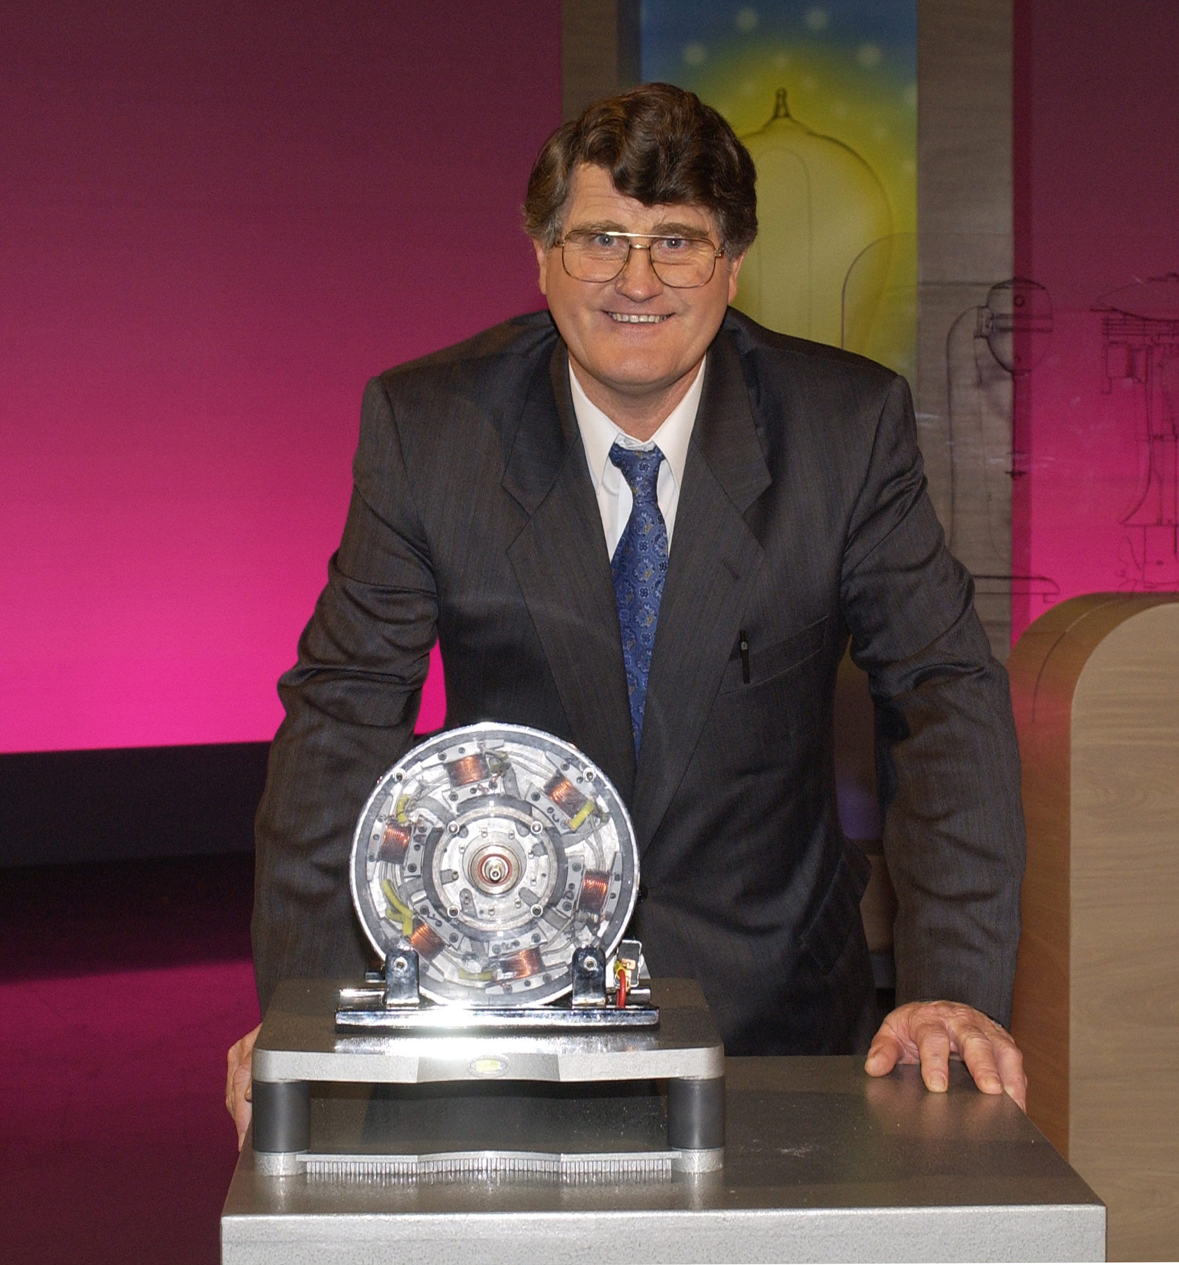

Development Plan

The Development Plan of the Company is to have working prototypes tested, to obtain

certified test results, on performance and efficiency levels. The working prototypes are all

the one physical size, but there are variations in the outside diameter of the copper wire

used, and the number of turns used on the energized coils. This effects the torque and

efficiency of the electric motor.

It has never been the intention that Gemini Electric Motor Company Pty.Ltd. would ever

manufacture in its own name. It may form another company to do the manufacturing if

necessary. The Ideal situation is for the company to be involved in Licensing and

Marketing, but if it is necessary, due to slow response by manufacturers, limited

manufacture can be considered.

Overall schedule

At this stage, we have achieved good working prototypes, soon to be tested.

It will be prudent to obtain formal certified test results, from an approved testing

authority. This could take several months. It must be remembered, that although the

working prototypes are going extremely well, the Inventor is not even an electrician, and

has no qualifications in electric motors. Once Qualified Electrical Engineers are put to

work on refining the Gemini Electric Motor, significant improvements can be expected.

The intention is for our company to concentrate on improving the power to weight ratio,

and efficiency of the electric motor, with licensed individual Manufacturers to modify the

electric motors to suit their requirements.

There are several Trade shows, and Exhibitions held around the world, where we would

show our new motor, as a stationary unit, or as a generator, and demonstrate some

applications, for example, as an electric bicycle, Solar car competitions, an electric

outboard and its application for wind generation. We will resist spreading ourselves into

too many applications, as it is obvious to any manufacturer, that a proven electric motor

can be made to their requirements.

The time frame before we could see money coming back to the Gemini Electric Motor

Company Pty. Ltd. could be within six months. It is the intention of the Directors to issue

bonus shares to the shareholders to maintain the real value of the company, as patents are

granted, or test results confirm the energy efficiency of the electric motor/ generator.

Risks

Because of the low technical design of the Gemini Electric Motor, it is an electric motor,

which can be made and repaired with minimal tooling or equipment. Because of this it is

assured of being manufactured in countries with a low technology base for the masses,

like China, India, Asia, Europe. At costs which will undercut existing electric motors.

The only Risk for a potential investor, is that they may miss out on the biggest

investment opportunity available this century. We only need one medium size investor,

the rest will miss out.

It was only last month that we have finally been in a position to demonstrate a reliable

Gemini Electric Motor. Once test results confirm our belief that by using both sides of the

energized coil, we will obtain more useable power from a given electrical current, the

investment opportunities for small to medium investors will be minimized.

Financial Statement and Projections

Gemini Electric Motor Company Pty.Ltd. has used shareholders funds and loans from

Ettridge Motors Pty.Ltd. as working capital, to purchase Patents, Components and tooling

to make working prototypes of the Gemini Electric Motor to the Inventors specifications.

We now have good working prototypes which can be evaluated. The Company has

almost run out of funds, and has changed the nominal capital of the company to

11,000,000 ordinary $1.00 shares and is issuing these additional 1,000,000 fully paid up

$1.00 shares in the company to raise the funds necessary to bring the Gemini Electric

Motor to commercial production or licensing.

There has never been a better opportunity to be part of an invention which has the

potential to realize a quick return on an investment, with long term capital growth. The

patents are good for 20 year terms, and each license negotiated increases the wealth of the

company.

It is expected that bonus shares will be issued to reflect the real value of the company,

once appropriate testing has been carried out.

The expected financial projections of the company for this year if the $1,000,000 is raised are :

- Pay deferred wages to the Managing Director, approx $134,000 ( annual salary at

the moment of $52,000 )

- Pay Back Loan monies to Ettridge motors Pty Ltd. $149,350

- Wages for working directors, $200,000 Expected at least two, possibly three

working directors.

- Cost of Directors Fees, and attendances $40,000

- Patent costs $50,000 approx. there are numerous patents being examined by

different countries, with annual continuation fees applying.

- Costs of producing working prototypes for testing $60,000

- Costs of having tests by approved testing authorities $50,000

- Costs of assistance by Electrical Engineers, and University Dept $45,000

- Attending Trade Shows and Exhibitions $ 150,000

- Costs of Legal Advise and preparation of Licensing Agreements in Australia, and

Overseas $80,000

10. Company Account keeping fees and advise $10,000

No allowance has been made for Office or factory costs, as we do not expect to employ

Office or factory staff in the early stages. The Inventor would continue to work from

home, and the costs are minimal. The Company will contract out any manufacture of

tooling for component parts and modifications to tooling

All costs are subject to variation depending on requirements.

Clearly we would keep spending within our ability to pay, the company will not be

allowed to incur costs that it cannot meet, and payments to Ettridge Motors, and the

Inventor will only occur if the larger sum is raised.

Appendix

Gemini Electric Motor Company Pty. Ltd.
ACN 092 633 246
Balance Sheet
As of June 30, 2004

Jun 30, '04
ASSETS
Current Assets
Current/Savings
A.N.Z. -20,953.49
Overseas payments for goods 4,696.83
Total Current/Savings -16,256.66
Total Current Assets -16,256.66
Other Assets
Licensing Agreement 100,000.00
Total Other Assets 100,000.00
TOTAL ASSETS 83,743.34
LIABILITIES & EQUITY
Liabilities
Current Liabilities
Accounts Payable
Accounts Payable 1,249.98
Total Accounts Payable 1,249.98
Other Current Liabilities
LOAN ACCOUNT 149,350.00
Deferred Superannuation 14,040.00
Deferred Wages 134,000.00
Tax Payable
GST
Tax Paid -13,399.77
Total GST -13,399.77
Tax Payable - Other 15,124.00
Total Tax Payable 1,724.23
Total Other Current Liabilities 299,114.23
Total Current Liabilities 300,364.21
Total Liabilities 300,364.21
Equity
Core Technology deduction 92,948.00
Tax Rebates 84,415.28
Shareholders Funds 45,000.00
Opening Bal Equity 104,734.55
Retained Earnings -403,683.22
Net Income -140,035.48
Total Equity -216,620.87
TOTAL LIABILITIES & EQUITY 83,743.34

